Kings & Quarry House Surgery Activity Data For March 2026

  Calls Handled by the Surgery:  3498 |   Calls Answered Within Two Minutes:  2792 |   Number of calls  Abandoned:  236 |   Text Messages Sent/received:  842
  Appointments Available:  2054 |   Appointments Seen:  1994 |   Appointments Missed:  172 |   Total Digital requests submitted to the Surgery:  755
    Administrative Communications Issued (letters/emails): 1231 | 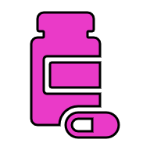  Items Issued Via Prescriptions:  3551 |   Medical Sick Notes Issued:  148 |   Referrals Made:  281

